# Phase 2: Org Setup & Configuration – Smart Healthcare CRM

## 1. Salesforce Edition

* **Edition Used:** Developer Edition
* **Reason:** Supports custom objects, Apex, Flows, Experience Cloud for Patient Portal, and integration APIs.

## 2. Company Profile Setup

| Field | Value |
| --- | --- |
| Company Name | Smart Healthcare CRM (Hospital) |
| Time Zone | IST (GMT+05:30) |
| Currency | INR |
| Notes | Aligns with hospital billing and Indian Standard Time |

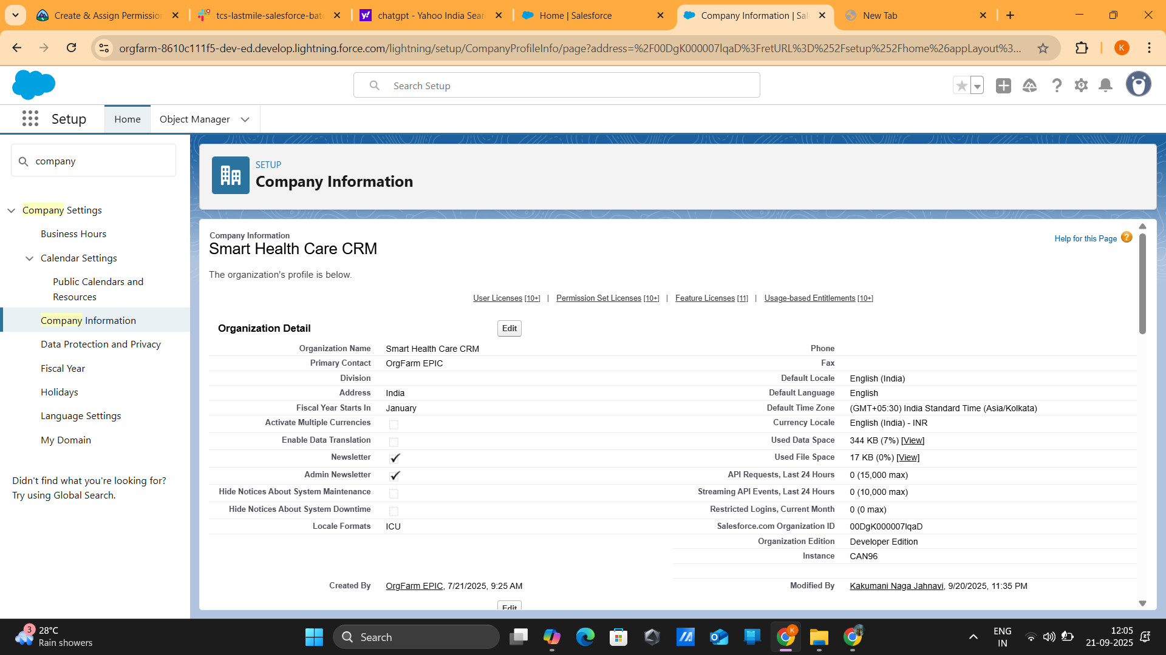

## 3. Business Hours & Holidays

| Field | Value |
| --- | --- |
| Working Hours | Mon–Sun, 9 AM – 9 PM |
| Holidays | National Holidays, Foundation Day |

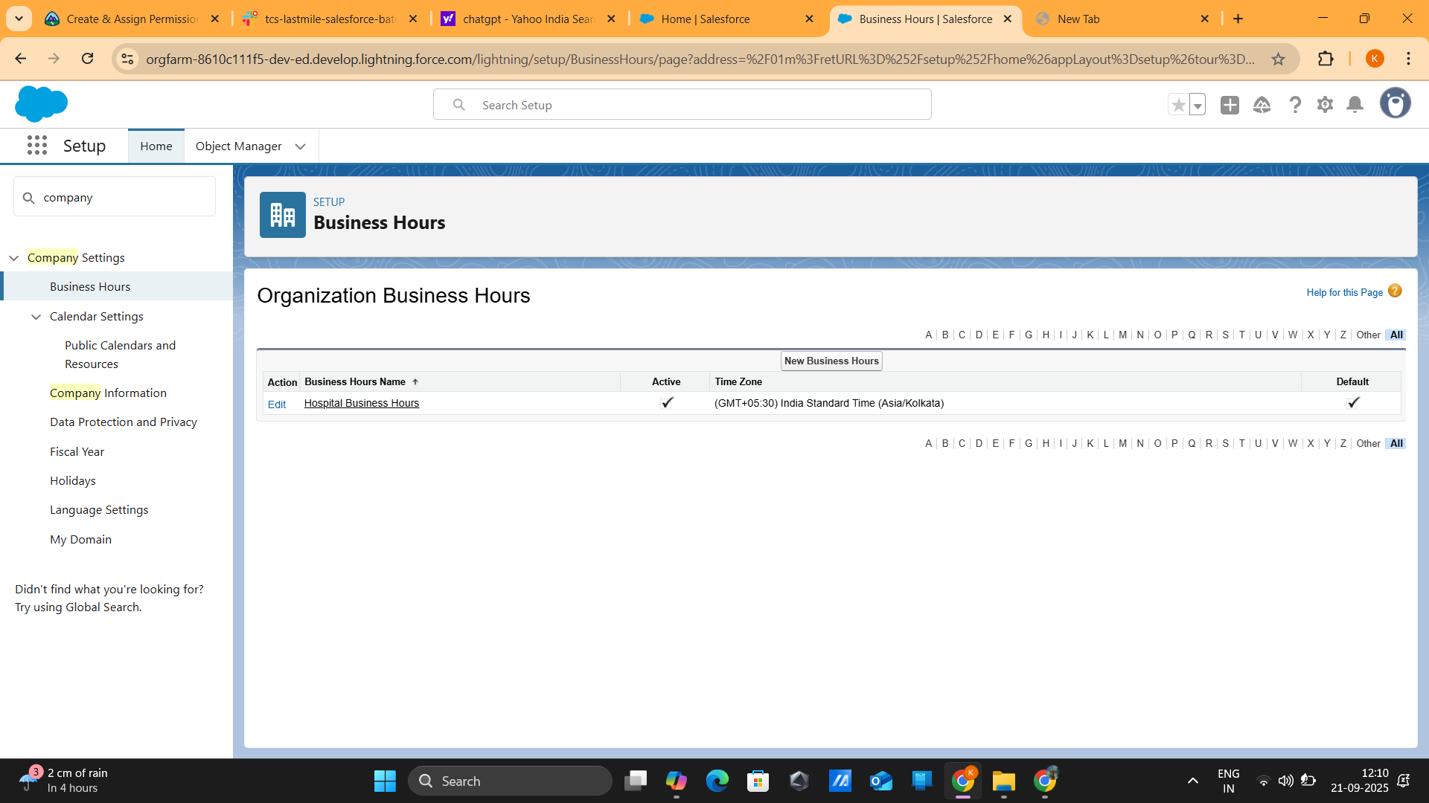

## 4. Fiscal Year Settings

| Field | Value |
| --- | --- |
| Fiscal Year Type | Standard Fiscal Year |
| Notes | April – March |

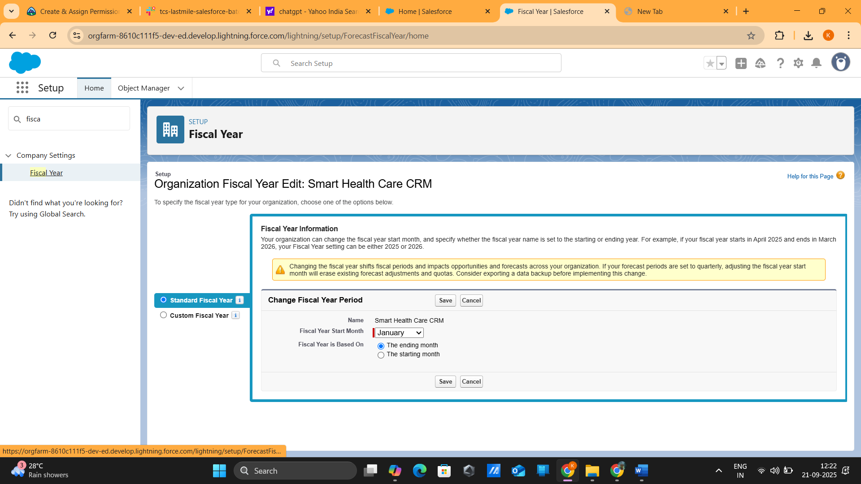

## 5. User Setup & Licenses

| Role | User Type | License Assigned |
| --- | --- | --- |
| Patient | Portal User | Experience Cloud License |
| Doctor | Standard User | Salesforce Platform License |
| Hospital Admin | Standard User | Salesforce License |
| Insurance Officer | Standard User | Salesforce License |
| System Admin | Super User | System Administrator License |

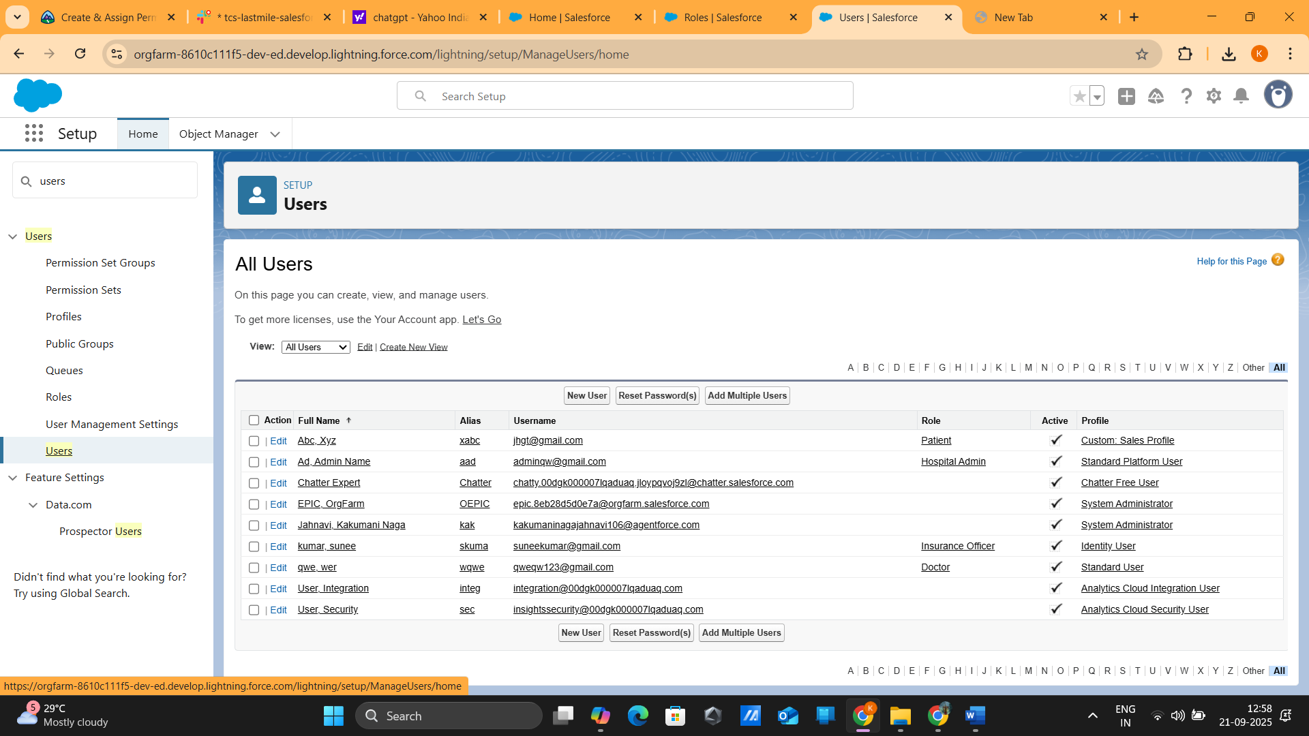

## 6. Profiles

| Profile | Access/Permissions |
| --- | --- |
| Patient Profile | Portal access (appointments & history only) |
| Doctor Profile | Read/write access for assigned patients & appointments |
| Hospital Admin Profile | Access to reports, dashboards, all objects |
| Insurance Officer Profile | Read/write on Claims object only |
| Admin Profile | Full Access |

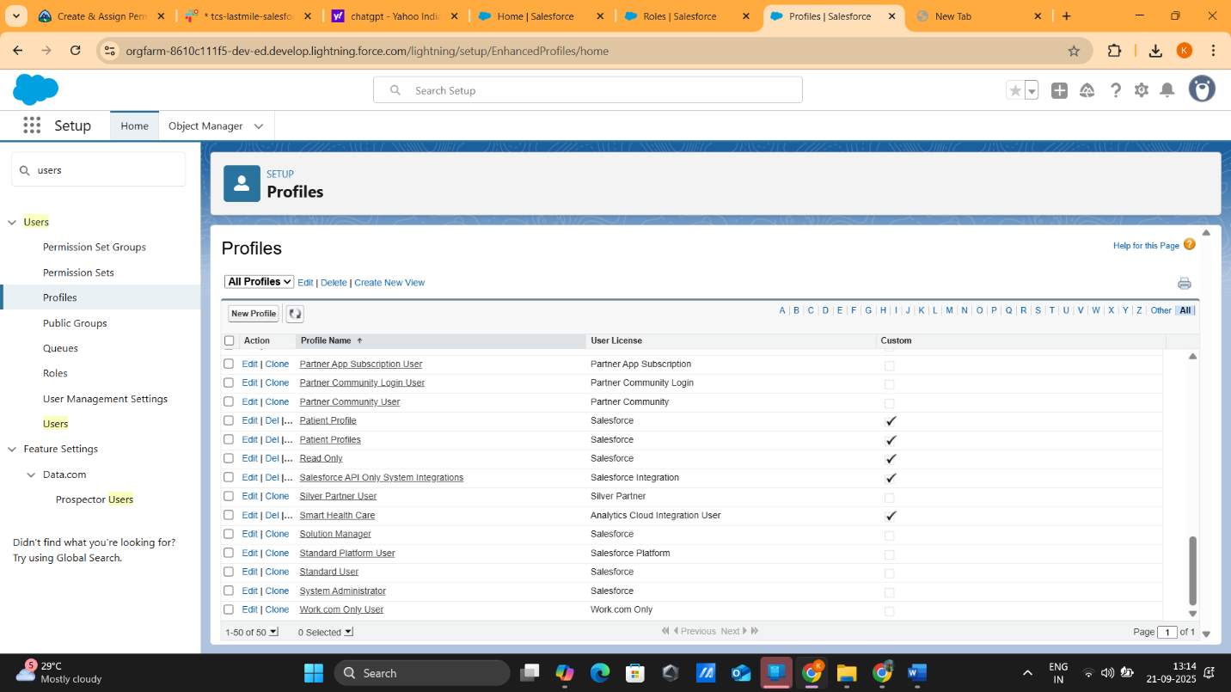

## 7. Roles & Role Hierarchy

* **System Admin** (Top level)
  + **Hospital Admin**
    - **Doctor**
      * **Patient (via lookup)**
  + **Insurance Officer**

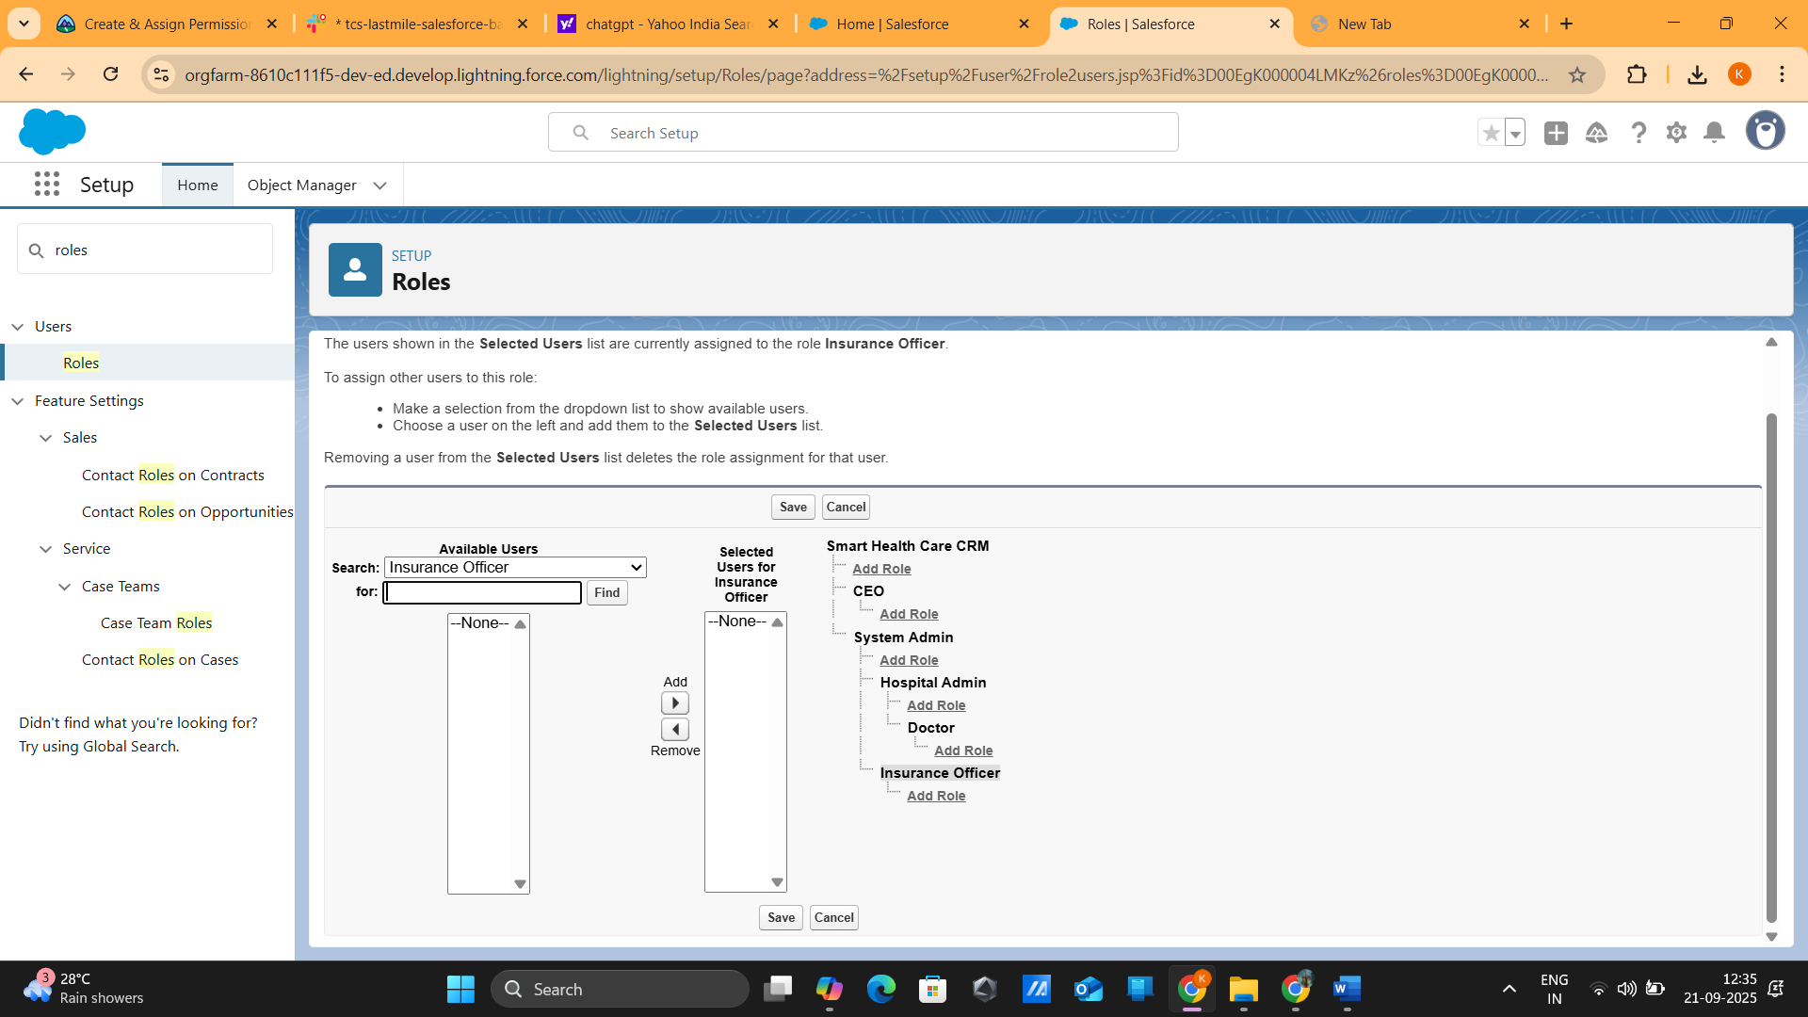

## 8. Permission Sets

| Permission Set | Assigned To | Access/Permissions |
| --- | --- | --- |
| Telemedicine Access | Doctors | Access telemedicine features |
| Insurance Claim Approvals | Insurance Officers | Approve and manage claims |
| Analytics Dashboard Access | Hospital Admins | View & manage dashboards |

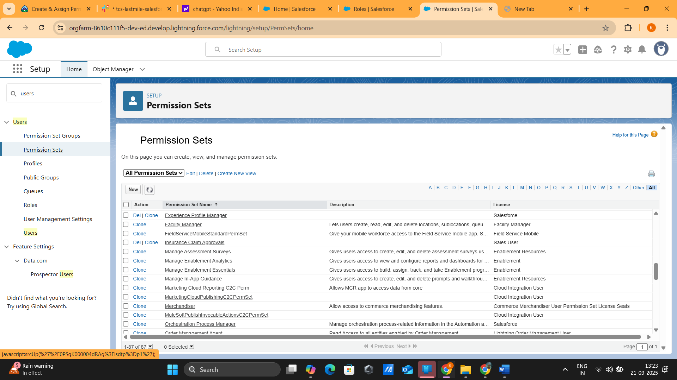

## 9. OWD (Organization-Wide Defaults)

| Object | Default Access | Notes |
| --- | --- | --- |
| Patient | Private | Only assigned doctor can view. |
| Appointment | Controlled by Parent | Linked to Patient |
| Insurance Claim | Private | Only Insurance Officer + Admin. |
| Prescription | Private | Shared with Doctor + Patient |

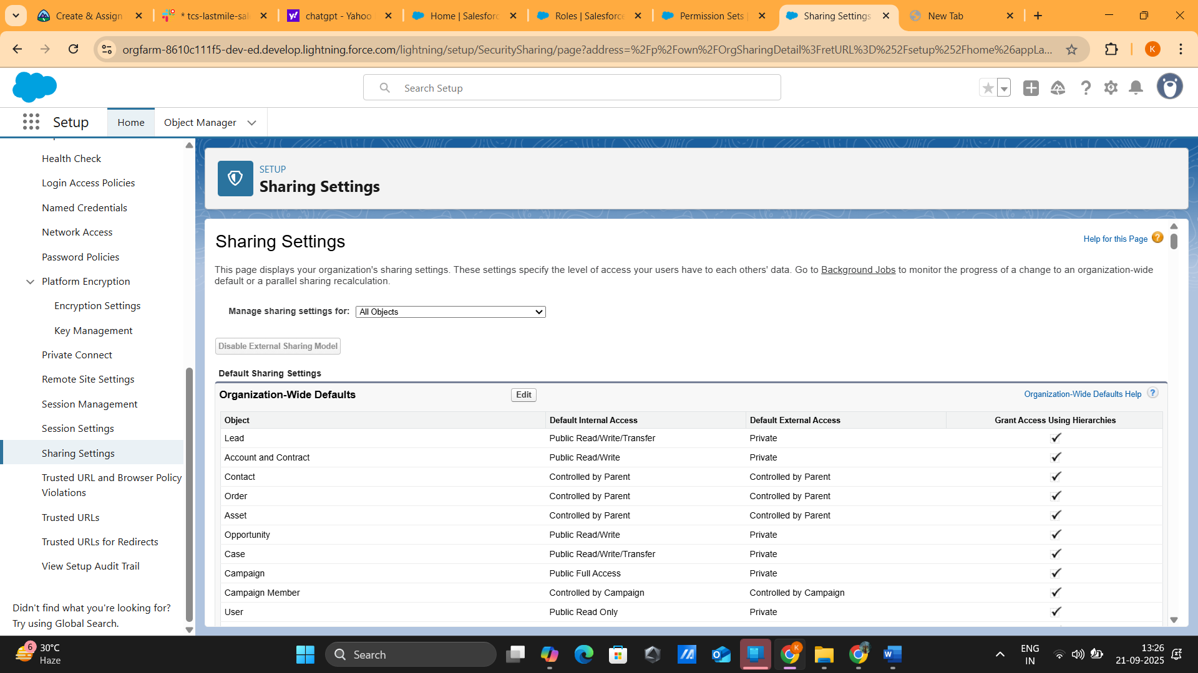

## 10. Sharing Rules

| Rule No | Object | Rule Description |
| --- | --- | --- |
| 1 | Patient | Share patient’s records with assigned doctor |
| 2 | Insurance Claim | Share insurance claim records with Insurance Officers |

## 11. Login Access Policies

| User Role | Policy |
| --- | --- |
| Admin | Restricted IP + MFA enabled |
| Doctors & Hospital Admin | MFA enforced |
| Patients | Portal login with OTP verification (future integration) |

### 📌 Deliverables / To-Do

1. Insert screenshots for:
   * Company Information
   * Business Hours & Holidays
   * OWD & Sharing Rules
   * Profiles & Permission Sets
2. Draw **Role Hierarchy diagram**.
3. Verify all users have correct **Profile, License, Role, and Permission Set** assignments.
4. Prepare **final Phase 2 document** ready for submission.